Ideation Phase
Define the Problem Statements

Date | 02 October 2026
Team ID | SWTID-2026-8608
Project Name | Pocket Smart AI – Your Smart Budget & Recommendation Assistant
Maximum Marks | 2 Marks

Customer Problem Statement Template:

Students and young individuals often struggle to manage their personal budgets and make informed spending decisions. They find it difficult to track expenses, understand their spending patterns, and identify suitable options within their budget. Existing budgeting methods are often manual and provide limited personalized guidance. Therefore, there is a need for an AI-powered solution that can analyze a user's budget and preferences and provide personalized recommendations to support better financial decisions.
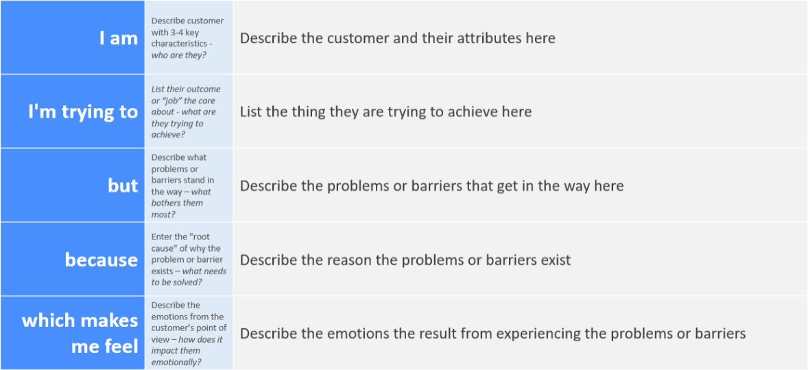

Example:

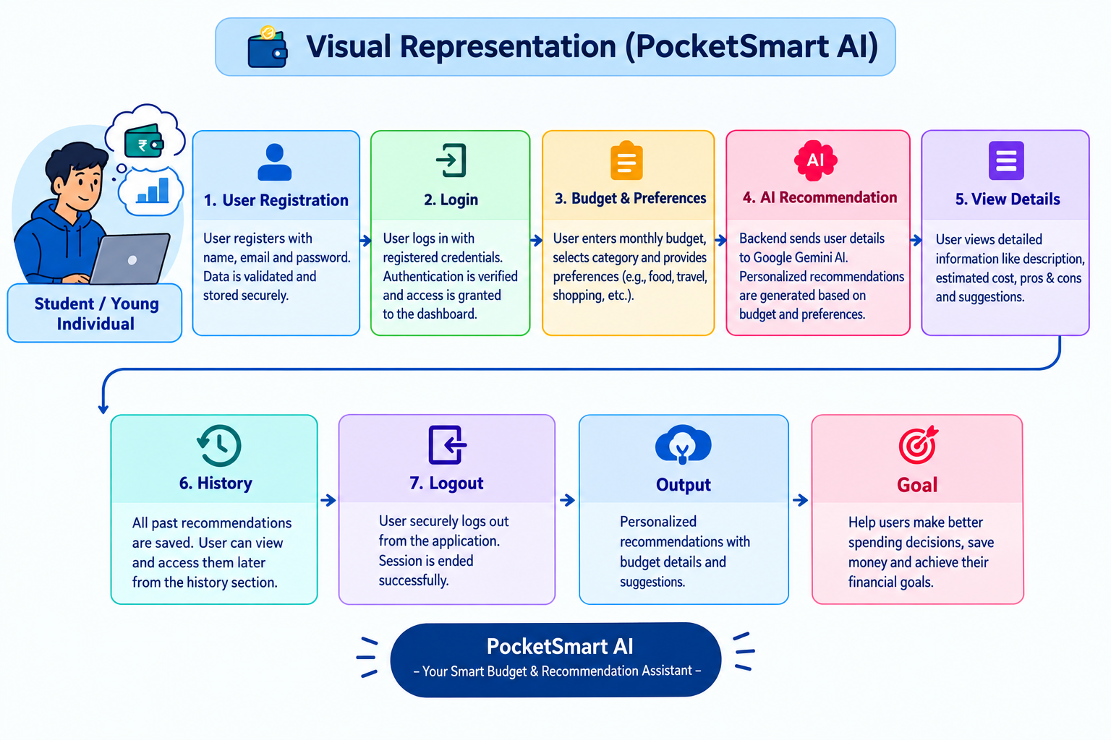

Problem  Statement (PS) | I am (Customer) | I’m trying to | But | Because | Which makes me feel
PS-1 | A student / young individual who wants to manage personal expenses | Track my daily expenses and manage my monthly budget | It is difficult to consistently track expenses and understand where my money is spen | Manual expense tracking is time-consuming and does not provide personalized | Confused and worried about managing my money effectively
PS-2 | A user looking for simple financial guidance | Get personalized recommendations based on my budget and preferences | Existing basic budgeting methods provide generic information | My spending data and preferences are not analyzed together to give personalized suggestions | Uncertain about what spending decisions I should make

